

Unit 3 ATAR Human Biology

Name:____________________________________________________________________

Test 3: The Immune system

|  |  |  |
| --- | --- | --- |
| Section | Marks available | Marks Achieved |
| A  Multiple Choice | 10 |  |
| B  Short Answer | 35 |  |
| C  Extended Answer | 10 |  |



**ATAR Human Biological Science Unit 3**

**Immune System**

Place a **X** through the best answer.

|  |  |  |  |  |  |
| --- | --- | --- | --- | --- | --- |
| **1** |  | (a) | (b) | ( c) | (d) |
| **2** |  | (a) | (b) | ( c) | (d) |
| **3** |  | (a) | (b) | ( c) | (d) |
| **4** |  | (a) | (b) | ( c) | (d) |
| **5** |  | (a) | (b) | ( c) | (d) |
| **6** |  | (a) | (b) | ( c) | (d) |
| **7** |  | (a) | (b) | ( c) | (d) |
| **8** |  | (a) | (b) | ( c) | (d) |
| **9** |  | (a) | (b) | ( c) | (d) |
| **10** |  | (a) | (b) | ( c) | (d) |
|  |  |  |  |  |  |
|  |  |  |  |  |  |
|  |  |  |  |  |  |
|  |  |  |  |  |  |
|  |  |  |  |  |  |

Section B: Short Answer

(35 marks)

Question 11 (11 marks)

The following question refers to the diagram shown below, which represents some of the

external defences to infection of the human body.

(a) In each box, explain how the structure indicated provides protection from infection.

(6 marks)

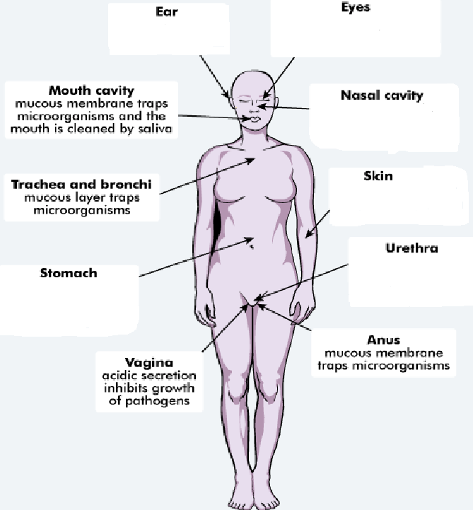

Acidic environment kills pathogens

Urine flow prevents growth of bacteria

Physical barrier that prevents pathogen entry

Cilia/mucus traps and removes pathogen

Tears contain chemicals that destroy pathogens/blinking

Wax prevents pathogens from entering

(b) An important strategy to reduce spread of infection is good personal hygiene.

List two strategies a person should follow to ensure good personal hygiene. (2 marks)

One: Any reasonable eg washing hands at appropriate times/ showering /washing clothes etc

Two: Any reasonable eg washing hands at appropriate times/ showering /washing clothes etc

(c) Inflammation is often a response displayed by the body when a pathogen has entered it.

Complete the table below, describing the action of each listed substance in the

inflammatory response. (3 marks)

|  |  |
| --- | --- |
|  | **Role in Inflammatory Response** |
| Heparin | Prevents blood from clotting |
| Histamine | Increases blood flow to the area |
| Phagocytes | Consume microrganisms and debris |

Question 12 (10 marks)

(a) Immunity can be classed as passive or active and natural or artificial. Complete the table

below, describing the different types of immunity. (4 marks)

|  |  |  |
| --- | --- | --- |
|  | Passive | Active |
| Natural | Passed through placenta/ passed through breast milk | Getting sick |
| Artificial | Injections of antibodies/Immunoglobulins (when infection is suspected) | Getting vaccinated |

(b) The diagram below shows one of the actions of antibodies on pathogens.

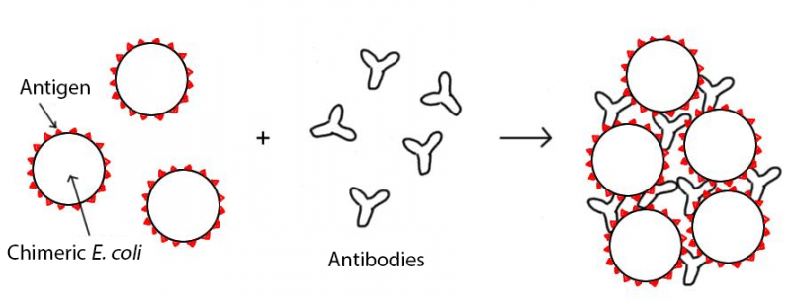

1. What action of antibodies does the diagram represent? (1 mark)

Agglutination

(ii) Describe three other ways in which antibodies can act on pathogens to help fight

infection. (3 marks)

One: Any of Binding to binding sites, making soluble antigens insoluble, inactivating/inhibiting reactions, coating them to increase phagocyte activity

Two: Any of Binding to binding sites, making soluble antigens insoluble, inactivating/inhibiting reactions, coating them to increase phagocyte activity

Three: Any of Binding to binding sites, making soluble antigens insoluble, inactivating/inhibiting reactions, coating them to increase phagocyte activity

(iii) Name the type of lymphocyte responsible for the production of antibodies.

B Cell/ Lymphocyte (1 mark)

(c) Vaccines are considered a safe and reliable way of increasing the immunity of

populations. However, there are risks associated with vaccines.

Identify one risk associated with the production or use of vaccines.

Allergic reaction/ cross contamination/ cross species contamination/ chemicals used in the preparation/ side effects. (1 mark)

Question 13 (14marks)

In the first few years of their life, babies and young children are attacked by many pathogens. Yet, they remain healthy and are well able to defeat and survive these pathogens. This is a result of the combined action of their Non-Specific Immune System, Passive Immunity and Active Immunity.

(a) Define the following terms and provide an example of each:

Pathogen: (2 marks)

An organism that causes disease: Any reasonable eg virus/bacterium or specific example

Non-Specific Immune System: (2 marks)  
(Reflexes, external defences or chemical processes) that stop any foreign substance from entering the body: Any reasonable eg ear wax, skin, inflammatory response.

Artificial Passive Immunity: (2 marks)  
When people are exposed to a disease and are provided with antibodies/immunoglobulins to prevent them from getting sick but no memory cells are formed: Any reasonable eg Rabies injections

In 2004, as part of the government’s public health programme, many children of school age were vaccinated against the disease whooping cough.

(b) On the axes presented below **draw** and **label** clearly the antibody response for a child who has been vaccinated against whooping cough andsubsequently is exposed to this disease. (4 marks)

1: correctly labelled axis

1: correct line

1: Primary response labelled

1:Secondary response labelled

Antibody

level

Secondary response

Primary response

Time

(c) Identify two different types of vaccine based on the substance they contain to cause an immune response. (2 mark)

Any two: Toxoid, subunit, dead, attenuated

(d) What is herd immunity? How does herd immunity protect individuals from contracting diseases?   
 (2 marks)  
When a large amount of individuals in a population are immunised: There is less chance of diseases being spread

Section C: Choose **ONE** of the two extended answer questions and write a response on the paper provided

Question 16. (10 marks)

1. Multiple drug resistant bacteria are becoming a problem in treating some bacterial infections. Bacteria that have evolved resistance to antibiotics cannot be controlled or treated

Researchers have suggested that the overuse of antibiotics in the community has caused the evolution of generations of multiple drug resistant bacteria. Explain how this resistance would occur if three antibiotics, A, B and C were used in sequence to treat a bacterial infection. (10 marks)

A) (Any 10)

* Natural genetic variation within the bacterial population
* Due to high mutation rate of bacteria
* Some are resistant to Antibiotic A
* When treated with Antibiotic A some bacteria survive
* These produce colonies resistant to Antibiotic A, antibiotic A no longer effective and a new antibiotic is needed
* Within these colonies there are bacteria resistant to Antibiotic B, the resistant ones will survive.
* These produce colonies resistant to Antibiotic A and B
* Antibiotic A and B no longer effective so new antibiotic needed.
* If bacteria are exposed to Antibiotic C some bacteria survive.
* Surviving bacteria resistant to all three antibiotics.

Question 17.

1. marks)
2. Antibiotics can be used to treat bacterial infections but are generally not effective against viral infections
3. Outline the reasons why antibiotics are ineffective against viral infections (3 marks)

• Antibiotics work on the cell structure/ block translation during protein synthesis

• Virus’s have no cell structure

• Viruses invade body cells to make more viruses

• Antibiotics cant distinguish infected body cells from normal body cells.

• Antibiotics work on bacterial cell walls, membranes and cellular metabolism

• The structure of virus protein coats do not have receptor sites for antibiotics.

1. What is an antiviral? Describe how antivirals work. (2 marks)

Must have

• Drugs which inhibit the action of viral pathogen

Any one of

• Work by targeting viral specific proteins and disabling them

• Can also enhance the bodies own immune system to attack the virus

• Work to inhibit the life cycle of the virus.

1. John was not immunised against whooping cough when he was an infant. As a teenager he was exposed to the pathogen that caused the disease and became ill. Jennifer was vaccinated as an infant and when exposed as a teenager she did not contract the disease and showed only very minor symptoms.
2. Explain the difference between Jennifer’s response and John’s response when they were exposed as teenagers to the pathogen (5 marks)

(Any 5)

• Jennifers was a secondary response

• Johns was a primary response

• Jennifer did not get any symptoms of the disease

• John was sick with the disease

• Jennifer produced many antibodies quickly

• Jennifer already had memory cells

• John had to undergo an immune response which took time

• John made memory cells